

Bharati Vidyapeeth’s

Institute of Management & Information Technology

C.B.D. Belapur, Navi Mumbai 400614

# Bharati Vidyapeeth's Institute of Management & Information Technology MCA Semester II AY 2020-21

**MCAL23: Robotic Process Automation INDEX**

# Name : MCA SEM II Division : A

|  |  |  |  |
| --- | --- | --- | --- |
| **Sr**  **No.** | **Date** | **Topic** | **Sign** |
| **1** |  | **Introduction to GUI of Tool** |  |
| 1.1 |  | Introduction to Automation Anywhere A2019 |  |
| 1.2 |  | Actions in Automation Anywhere A2019 |  |
| 2 |  | **Automation anywhere Basic Commands:** |  |
| 2.1 |  | Launching a website (Facebook) |  |
| 2.2 |  | Bot to work with MSPaint |  |
| 2.3 |  | Automate action of getting the title of active window |  |
| 2.4 |  | Automate action of closing a notepad window |  |
| **3** |  | **Automation anywhere Advanced Commands:** |  |
| 3.1 |  | To automate the task of extracting the data from multiple PDF documents and storing the data into a text file. |  |
| 3.2 |  | To automate the task of extracting the data from multiple PDF documents and storing the data into a csv file. |  |
| 3.3 |  | Automate task of replacing few characters from a string |  |
| 3.4 |  | Automate task of copying files from a source folder to destination folder |  |
| 3.5 |  | Extract a table from webpage |  |
| 3.6 |  | Bot to extract text from notepad file and copying it into excel |  |
| 3.7 |  | Extracting Text from Image |  |
| **4** |  | **RPA for Excel Commands:** |  |
| 4.1 |  | To automate the task of extracting the data from an Excel File according to some condition and storing the extracted data in another File. |  |
| **5** |  | **Advanced RPA Techniques:** |  |
| 5.1 |  | Design IQ BOT |  |
| **6** |  | **Use of UI Path Tool** |  |

**MCA SEMESTER II**

# Robotic Process Automation Course Code: MCALE23 Assignment 1.1

**Topic : Introduction to Automation Anywhere A2019 Define RPA:**

Robotic Process Automation is entity which mimics human actions with sequence of steps automatically i.e. without human intervention.

# Why to use RPA:

1. Customer Satisfaction – reduce manual errors and faster services
2. Analytics – improve data quality and increase scope of data collection
3. Compliance – reduce human contact with sensitive data and reduce fraud.

# Benefits of RPA:

1. Reduce Burden on IT: Does not disturb underlying legacy systems
2. Reliability: Bots can work 24*7 effectively
3. Cost Cutting Technology: Reduces the size of the manual workforce and hence reduce costs
4. No Coding Required: Programming skills are not necessary
5. Accurate: Less prone to errors and functions with accuracy and uniformity.
6. Productivity Rate: Execution time much faster than manual process approach
7. Compliance: Follows rules to provide audit free trail
8. Consistency: Repetitive tasks are performed in the same manner each time

# What can we automate using Robotic Process Automation?

* + Excel HTML
  + JAVA
  + ERP
  + Email
  + PDF
  + Web App
  + Desktop App
  + Image

# Automation Anywhere Architecture:

* + - Client Server Architecture
    - Bot Creator is the Developer Client
    - Bot Runner is the runner client
    - Control Room is the server

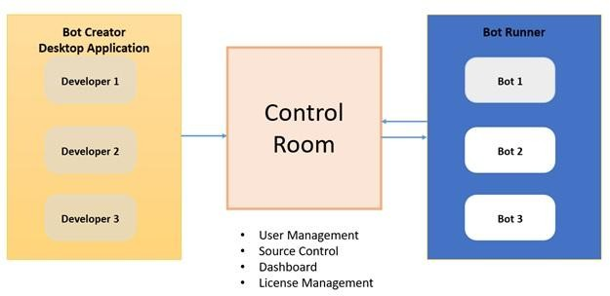

# Create your First Bot:

Steps to follow

1. Open Community Edition Account: https://www.automationanywhere

.com/products/enterprise/community-edition

1. Login to Control Room
2. Install BotAgent and connect device

# Bot: Display Hello Message

Step 1: Add Message box action and Enter the message: “Hello..!!!”

**Bot Name**: HelloMessagebot

# Recorder:

* + Can works on Web and desktop application
  + Recorder is object oriented as it captures object controls such as Buttons, textboxes etc.
  + Captures Keystrokes and mouse click

# Flow

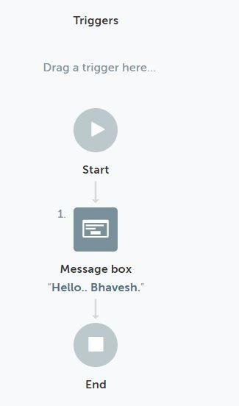

**Output:**

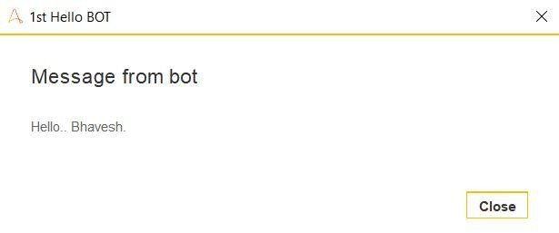

# MCA SEMESTER II

**Robotic Process Automation Course Code: MCALE23 Assignment 1.2**

# Topic : Actions in Automation Anywhere A2019 Variable:

It is the containers where you can store any type of data e.g. string, numbers etc.

# Types of Variable:

1. User (Local) Variables
2. System Variables
3. Credential Variables

# User Variable:

Used for a specific task or set of tasks

A user variable can hold one value or multiple values

# System Variables:

In the System variables, there are pre-defined variables that are provided by Automation Anywhere. System variables are available to be used in all automation tasks. System Variable types include the following components as follows.

# Date and Time System Variables –

System-related date and time variables.

# System Variables –

Loop: Useful in conjunction with Loop commands.

# Excel System Variables –

Useful for Excel automation.

# Email System Variables –

Useful for Email automation.

# Trigger Variables –

Useful in conjunction with triggers.

# PDF System Variables –

Useful to be used with PDF command.

# System Variables –

Specific to System Settings/Parameters Variables specific to a particular client machine.

# Credential Variables:

Credential variables store sensitive information that’s used when running automation tasks. Credential variables can be used only by the Bot Creator and only in Command fields that need a credential input.

# Actions:

**These are** essential building blocks of a Bot. They are the commands that tell a Bot what to do.

Actions are grouped into packages.

For example, the **File package** contains File related actions, such as Create, Open, Delete, Print Multiple files and Rename that you can insert into the Bot editor to automate a process working with files.

**Excel advanced package** contains Excel-related actions, such as **Open**, **Go to cell**,

and **Delete cells**, that you can insert in to the Bot editor to automate a spreadsheet process.

# String Operation:

Methods to Manipulate and Extract Strings

* + **Assign** – assigns a value or a variable value to another string variable

# Extract Text –

Use the before, before and/or after, or the after settings to extract a sub-string from a body of text.

* + - Before: You provide the text that precedes the text you’re interested in extracting, and the action will return everything that comes after.
    - Before and After: You provide the text that precedes the text you’re interested in as well as the text which comes after the text you’re interested in. The action will return all the text that comes between the two.
    - Before or After: You provide the text that may precede the text you’re interested in as well as the text which may come after the text you’re

interested in. The action will attempt to return the preceding/subsequent text.

* + - * Note: Be sure to do lots of testing when using Before or After so you know exactly what kind of text the bot should expect as a return
    - After: You provide the text that comes after the text you’re interested in extracting, and the action will return everything that comes before.

# Compare –

Compares two strings and returns True if the strings are identical.

# Uppercase –

Converts the source string to upper case.

# Length

Gets the length of a string.

# Split –

Splits the source string into multiple strings using a delimiter.

# To Boolean

Splits the source string into multiple strings using a delimiter.

# Substring –

Extract part of a larger body of text based on a start position and optional length. The optional length lets you specify how many characters you intend to extract; the alternative is that text from the starting position through the end of the provided source string would be extracted.

# Find –

* + - returns the position of matching text within a larger body of text.
    - Can be hard-coded text, or could be a regular expression.

# Replace -

Splits the source string into multiple strings using a delimiter.

# Lowercase –

Splits the source string into multiple strings using a delimiter.

# Reverse –

Splits the source string into multiple strings using a delimiter.

# Trim –

Splits the source string into multiple strings using a delimiter.

# To Number –

Splits the source string into multiple strings using a delimiter.

# If statement:

Conditional Statement which executes a task if the condition is either true or false

# Conditions for if Statement:

Number/String/Boolean Windows exists

Web Control Exists Task/Script Exists File/Folder Exists Data Table

Date Time

# Bot: To open calculator if it isn’t open

Step 1: Check if the Calculator is open. In **If action** select the condition **Window exists.**

Select the calculator application from the Windows option

* 1. Display **Message** “Calculator already open”

Step 2: If not open the calculator. Add **Else** action and have **Application:open** action to open the calculator application

Step 3: Close the program. Close the appilication

**Bot Name**: If_Statement If :

Else :

# Flow:

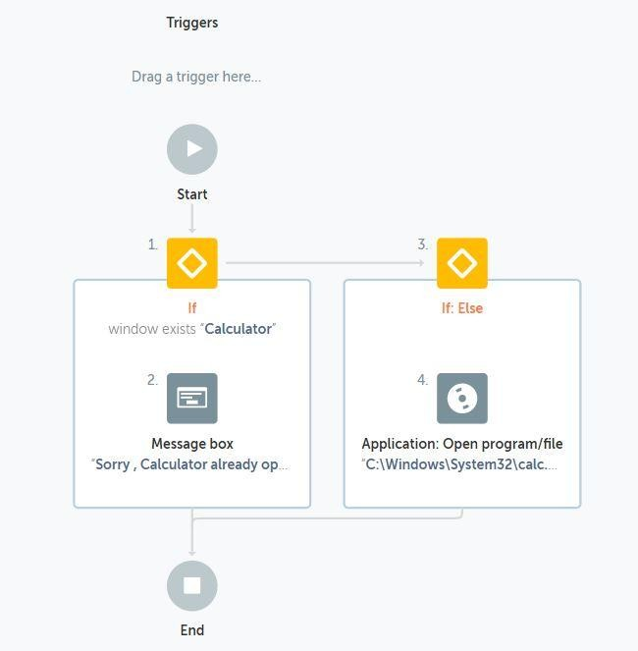

**Output:**

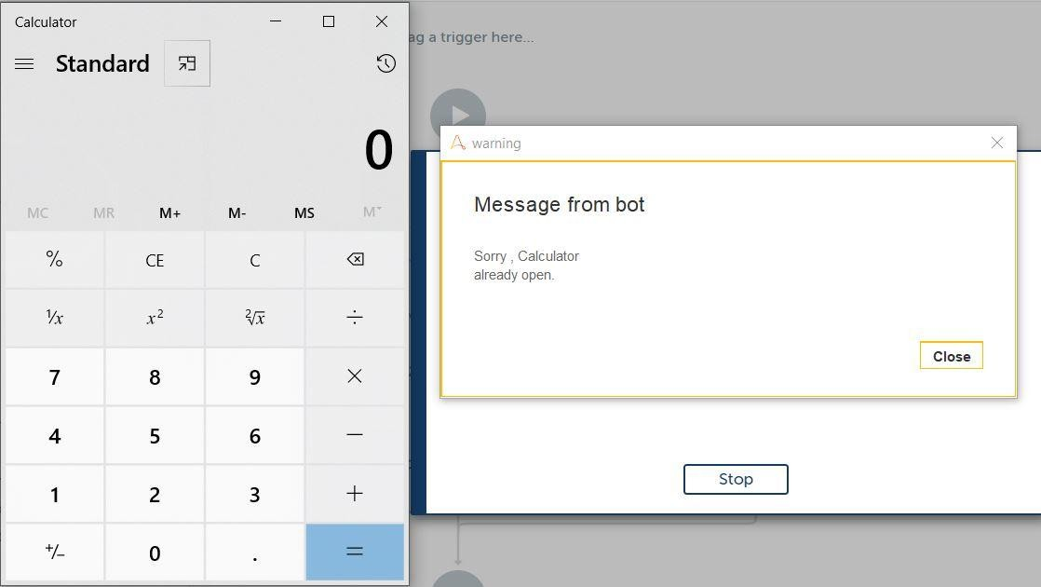

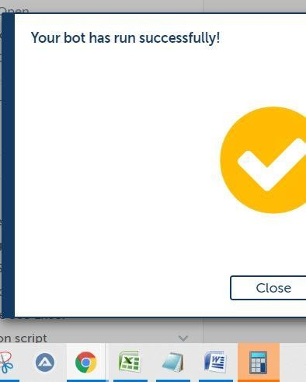

# MCA SEMESTER II

**Robotic Process Automation Course Code: MCALE23 Assignment 2.1**

# Bot :Launching a website (Facebook)

Step 1: Open the website using **Browser:Open** action

1. Select the **Browser** tab
2. Provide **Link to open** <https://www.facebook.com/>

Step 2: Using **Recorder: Capture** to simulate an object's click event

1. Using **Capture: Object** to capture the input box to provide the **email id**
2. Select **Action** as **Set text**
3. Enter **Keystrokes** with the email id with which you wish to log in Step 3: Using **Recorder: Capture** to simulate an object's click event
4. Using **Capture: Object** to capture the input box to provide the **password**
5. Select **Action** as **Set text**
6. Enter **Keystrokes** with the password with which you wish to log in Step 4: Using **Recorder: Capture** to simulate an object's click event
7. Using **Capture: Object** to capture the **Login Button** click
8. Select **Action** as Left Click
9. Enter **Keystrokes** with the password with which you wish to log in

**Bot Name**: FacebookLauncher

# Flow :

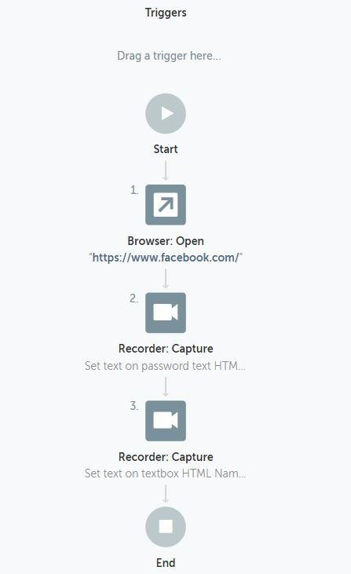

**MCA SEMESTER II**

# Robotic Process Automation Course Code: MCALE23 Assignment 2.2

**Bot: Bot to work with MsPaint**

Procedure

1. Open a new bot:
   1. From the Automation Anywhere Enterprise web interface, select **Bots** > **My bots**.
   2. Click **Create new** > **Bot**.
   3. In the Create Task Bot window, enter a bot name.
   4. Accept the default folder location **\Bots\**.

To change where your bot is stored, click **Choose** and follow the prompts.

* 1. Click **Create and edit**.

1. Insert a **Application: Open program/file** action.
   1. Click **Actions**.
   2. Search for the Application package.

Click in the **Actions** search box and enter Application. Click the arrow to expand the Message Box options.

* 1. Double-click or drag the **Open** action to the Bot editor (open space to the right).

1. In the dialog box on the right, specify the fields for the **Open program/file** action.
   1. In the **Location of the program/file** field, browse the path for MSpaint.exe
2. Insert **Recorder: Capture** action
   1. Click **Actions.**
   2. Search **Capture** Action from Recorder package
   3. In the dialog box set the Paint application.
   4. In **Capture object,** capture any colour from the palate. Select **Left Click** from Action
3. Insert **Recorder: Capture** action
   * 1. Click **Actions.**
     2. Search **Capture** Action from Recorder package
     3. In the dialog box set the Paint application.
     4. In **Capture object,** capture **Fill with colour tool**. Select **Left Click** from Action
4. Insert **Recorder: Capture** action
5. Click **Actions.**
6. Search **Capture** Action from Recorder package
7. In the dialog box set the Paint application.
8. In **Capture object,** capture **the area to be filled with the colour**. Select **Left Click** from Action
9. Click **Save**.

Your bot is now ready to run.

1. Test your bot.

Click **Run** at the top right.

The bot fills the area with the colour selected from the colour palate using the fill with colour tool.

Bot Name: MSPaintBot

# Flow

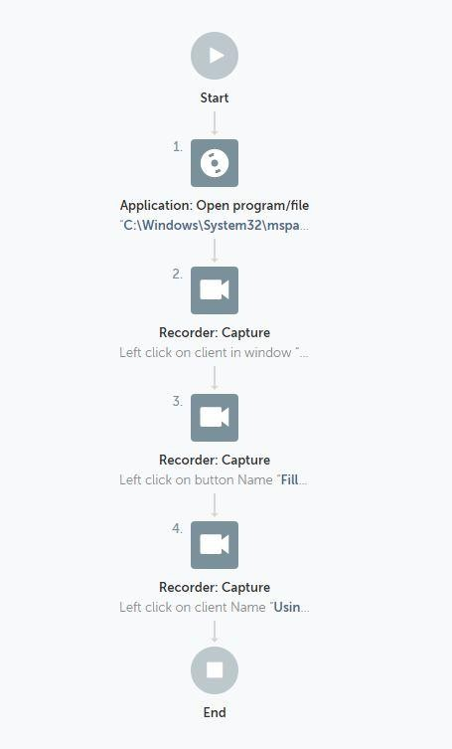

**MCA SEMESTER II**

# Robotic Process Automation Course Code: MCALE23 Assignment 2.3

Bot: **To get the Title of Active Window**

Procedure

1. Open a new bot:
   1. From the Automation Anywhere Enterprise web interface, select **Bots** > **My bots**.
   2. Click **Create new** > **Bot**.
   3. In the Create Task Bot window, enter a bot name.
   4. Accept the default folder location **\Bots\**.

To change where your bot is stored, click **Choose** and follow the prompts.

* 1. Click **Create and edit**.

1. Insert a **Window** action.
   1. Click **Actions**.
   2. Search for the Window package.

Click in the **Actions** search box and enter window. Click the arrow to expand the Window options.

* 1. Double-click or drag the **Activate** action to the Bot editor (open space to the right).

1. In the dialog box on the right, specify the conditions for the **Activate** action.
   1. In the **Choose an application window** field, select word document file which is open
2. In the dialog box on the right, specify the conditions for the **Minimize** action.
   1. In the **Choose an application window** field, select word document file which is open
3. In the dialog box on the right, specify the conditions for the **Maximize** action.
   1. In the **Choose an application window** field, select word document file which is open
4. In the dialog box on the right, specify the conditions for the **Get Active Window Title** action.
   1. In the **Assign the windows title variable** field, enter variable name WindowsTitle1 to have Title bar details
5. In the dialog box on the right, specify the conditions for the **Get Active Window Title** action.
   1. In the **Assign the windows title variable** field, enter variable name WindowsTitle1 to have Title bar details
6. Click **Save**.

Your bot is now ready to run.

1. Test your bot.

Click **Run** at the top right.

The bot displays a Message box with the text Go be great!.

In the following steps, you configure a variable and insert it in the Message box.

1. Create a variable.
   1. Click **Variables** from the accordion menu on the left panel.
   2. Click **Create variable** (the + sign).
   3. Enter vHelloWorld in the name field.
   4. Select the **Use as output** option.
   5. Enter Say Go be Great! with a variable in the **Default value** field.
   6. Click **Create**.
2. Assign the vHelloWorld variable to the **Enter the message to display** field.
   1. Click the **Message box** action in the Bot editor.
   2. In the dialog box, delete the text from the **Enter the message to display** field.
   3. Either press the F2 key or click the **Insert variable** icon.

The **Insert variable** icon is located on the right-side of the text field.

* 1. Select vHelloWorld from the drop-down list.
  2. Click **Yes, insert**.

1. Click **Save**.
2. Click **Run**.

The bot displays a Message box with the text Say Go be Great! with a variable.

Bot Name: CaptureTitleActiveWindow Variable Name: WindowTitle

# Flow

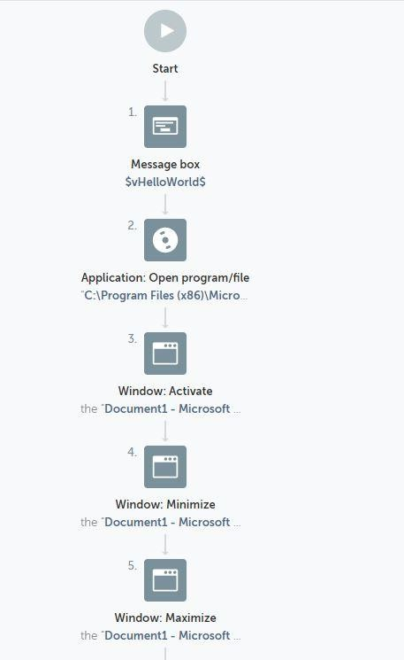

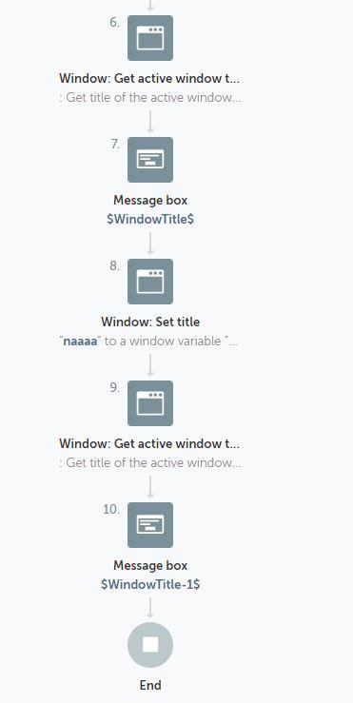

**Bot: To close notepad**

# MCA SEMESTER II

**Robotic Process Automation Course Code: MCALE23 Assignment 2.4**

Procedure

Follow these steps to add a **Click** action:

1. In the **Actions** palette, double-click or drag the **Click** action from the **Mouse** package.
2. Specify the window in which to capture the mouse click: Choose from the **Application**, **Browser**, or **Variable** tab.
3. Click **Capture coordinate**. The selected window appears.
4. Drag the mouse to select the click spot and left-click to capture it.

The captured spot appears in the **Preview** section with the coordinates underneath.

1. In the **Button** option, specify the button to click.

Choose from **Left Button**, **Right Button**, or **Middle Button**.

1. In the **Event** option, specify the event.

Choose from **Click**, **Double click**, **Button up**, or **Button down**.

1. Click **Save**.

Bot Name: CloseNotepad

# Flow

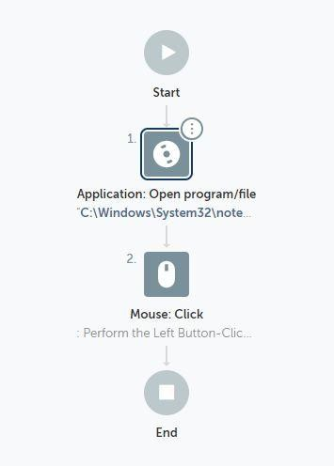

**MCA SEMESTER II**

# Robotic Process Automation Course Code: MCALE23 Assignment 3.1

**Bot : To automate the task of extracting the data from multiple PDF documents and storing the data into a text file.**

Step 1: Using Loop

* 1. Set **Iterator** as Files in each folder
  2. Specify the Folder Path D:\Sudeshna2021\RPA\Purchase Order containing the PDF Files
  3. Assign File name and extension to a dictionary variable FilesInFolder2

Step 2: Inside the loop

1. Using **Application: Open** open each of the program file in D:\Sudeshna2021\RPA\Purchase Order\**$FilesInFolder2{name}$**.**$FilesInFolder2{extension}$**
2. Using **PDF: Extract text** export data to a text file D:\Sudeshna2021\RPA\Log File\Log File for image text.txt

**Bot Name**: ExtractMultiplePDFtoText

# Flow

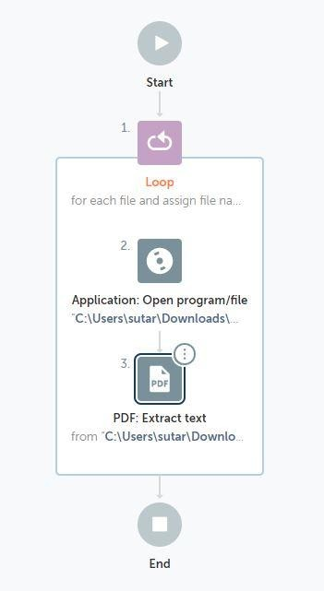

**MCA SEMESTER II**

# Robotic Process Automation Course Code: MCALE23 Assignment 3.2

**Bot : To automate the task of extracting the data from multiple PDF documents and storing the data into a CSV/Excel file.**

Step 1: Using **Excel advanced: Open** action open a Excel file D:\Sudeshna2021\RPA\Log File\Bill.xlsx. Select **Sheet contains a header** option. Open the file in **Read-Write mode** only

Step 2: Using Loop

* 1. Set **Iterator** as Files in each folder
  2. Specify the Folder Path D:\Sudeshna2021\RPA\Utility Bill containing the PDF Files
  3. Assign File name and extension to a dictionary variable FilesInFolder3

Step 3: Inside the loop

1. Using **PDF:Extract field** action specify the path D:\Sudeshna2021\RPA\Utility Bill

\**$FilesInFolder3{name}$**.**$FilesInFolder3{extension}$.** Extract fields Invoice Number and Invoice Date from the file. Map each key name extracted to a variable name.

1. Using **Excel advanced: Set cell** add the $InvoiceNo$ variable to the active cell
2. Using **Excel advanced: Go to cell** go to one cell right to the active cell
3. Using **Excel advanced: Set cell** add the $InvoiceDate$ variable to the active cell
4. Using **Excel advanced: Go to cell** go to one cell below to the active cell
5. Using **Excel advanced: Go to cell** go to one cell left to the active cell

**Bot Name**: ExtractMultiplePDFtoExcel

# Flow

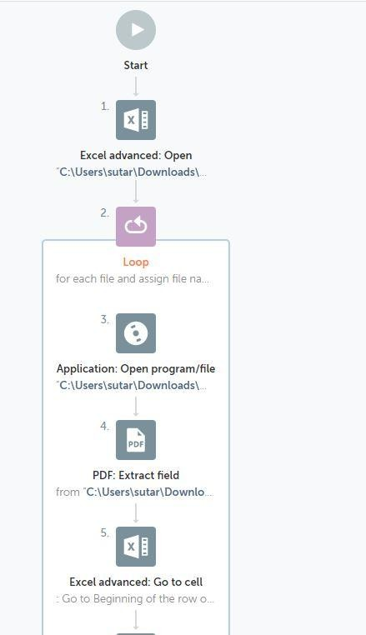

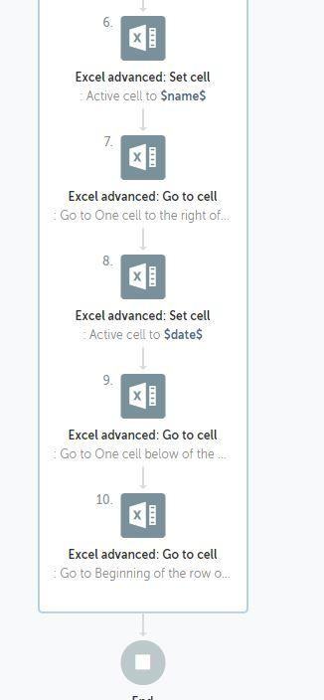

**Bot : Automate task of replacing few characters from a string**

Procedure:

Step 1: Create a String variable $str1$ and assign value to it

Step 2: Using **String:Replace** replaces specified part of a 'Source string' with a 'Replacement string'

3. Display the resultant string in the message box

**Bot Name**: ReplaceTextInString

# Flow

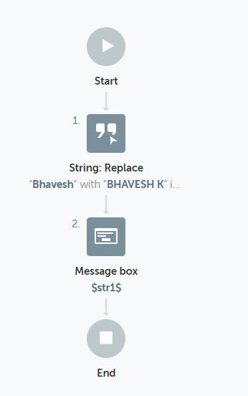

**MCA SEMESTER II**

# Robotic Process Automation Course Code: MCALE23 Assignment 3.4

Bot: To Automate task of copying files from a source folder to destination folderTask:

1. Select source folder to copy
2. Create destination folder
3. Copy files
4. Zip the copied files

Procedure

1. Create folder from folder package (Give path)
2. Create file from file package (Give Path)
3. Copy file from file package (Give source and destination path)
4. Copy action from folder package (Mention source file and destination folder)
5. Use zip action from folder. (Specify files to compress, destination zipped file)
6. Save

Bot Name: copyFolder

Source Folder: G:\Teaching2021\SEM002\MyDoc\MyNewFolder Destination folder: G:\Teaching2021\SEM002\MyDoc\MyNewFolder1

Practical Name: Bot to Automate task of creating files inside a folder and zipping it. Procedure

Bot Name: createFilesNZip Zip File: myZip.zip

# Flow

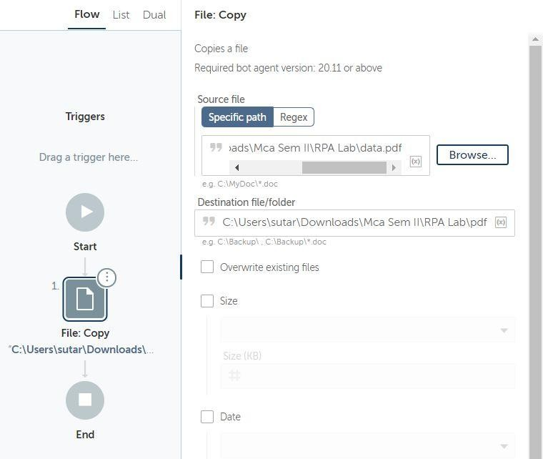

**MCA SEMESTER II**

# Robotic Process Automation Course Code: MCALE23 Assignment 3.5

**Bot: Extract a table from webpage**

This example uses actions from the Browser, Data Table, Recorder, and Window packages. To extract data from a table, do the following steps:

Procedure

1. Open a new bot:
   1. From the Automation Anywhere Enterprise web interface, select **Bots** > **My bots**.
   2. Click **Create new** > **Bot**.
   3. In the Create Task Bot window, enter a bot name.
   4. Accept the default folder location **\Bots\**.

To change where your bot is stored, click **Choose** and follow the prompts.

* 1. Click **Create and edit**.

1. Open a browser window to the web page from which you will extract the table.
   1. Double-click or drag the **Browser** > **Open** action.
   2. In the URL field, enter https://en.wikipedia.org/wiki/United_States_at_the_Olympics
   3. Select your preferred browser.
   4. Click **Save**.
   5. Click **Run**.

The bot opens the window.

1. Specify the table.
   1. Double-click or drag the **Recorder** > **Capture** action.

Click the **Browser** tab and select <https://en.wikipedia.org/wiki/United_States_at_the_Olympics>from the drop- down list.

If the window title does not appear in the list, click **Refresh**.

* 1. Click **Capture object**.
  2. Hover over the table in the page.

An orange box appears, surrounding the table.

* 1. Click the table.

The Object Processing message box appears.

* 1. Return to the Enterprise Control Room.
  2. In the Object properties table, verify the Control Type is TABLE. If it is not, click **Recapture object**.
  3. From the **Action** drop-down list, select **Get table**.
  4. In the **Assign output to variable** field, create the tHostingGaames. The Daily Stock Market Overview window is saved as the variable window-1.

1. Specify the file where to save the data.
   1. Double-click or drag the **Data Table** > **Write to file** action.
   2. From the **Data table name** list, select tHostingGaames.
   3. Provide a file path to create a CSV file.

For example, G:\Teaching2021\SEM002\RPA\Practical\RPA Orientaton Matrial_NMITD\RPA Orientaton Matrial\RPA Practicals\HostingGames.csv.

* 1. Select the **Create folders/files if it doesn't exist** option.
  2. Select to overwrite the existing file.

1. Click **Save**.
2. Click **Run**.

The bot creates a CSV file on the desktop with data on seven indexes, their values, and net change.

Bot Name: WebTableExtractBot

Csv file name : RPA Lab\csv\gettable.csv

# Flow

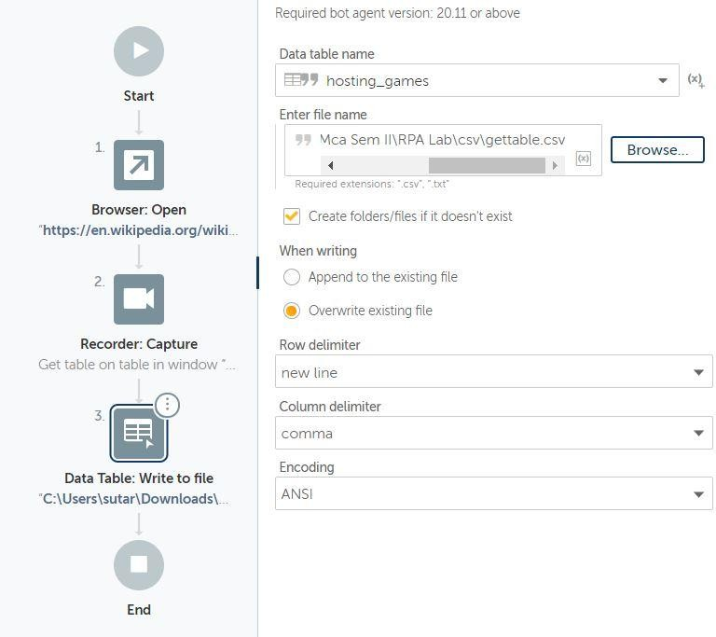

**MCA SEMESTER II**

# Robotic Process Automation Course Code: MCALE23 Assignment 3.6

Bot: To extract string from TXT file and copy it into excel file

Procedure

1. Open TXT file (CSV/TXT package)
2. Open Excel File (Basic Excel PAckage)
3. Select Cell in Excel sheet from where contents to be pasted. (Go To Cell” Basic Excel Package)
4. Loop (For each row in CSV/TXT)
5. Messagebox (Just to display contents of each row)
6. Set Cell mention variable name with index (mentioned in loop). (Set Cell” Basic Excel Package)
7. GoTo Cell (for next data in next cell)
8. Set Cell.
9. Repeat for each column
10. For next row, Go To cell: (mention “Go to Beginning of the row” in active cell)
11. Click **Save**.
12. Close file

Bot Name: ImpBot Notepad file: Extract.txt Excel File: Txtto Excel.xlsx

# Flow

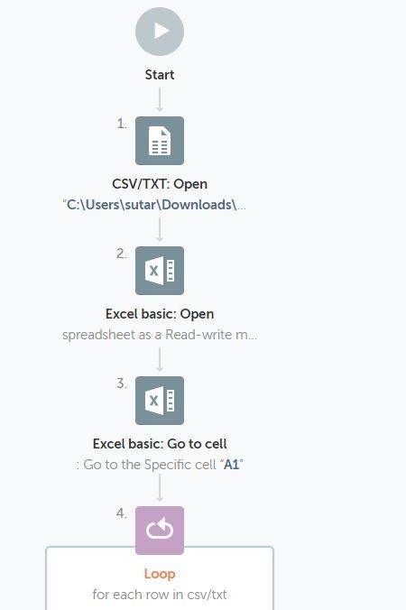

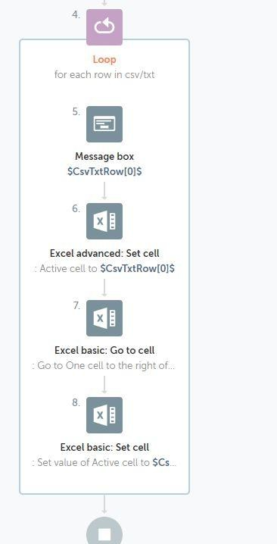

**MCA SEMESTER II**

# Robotic Process Automation Course Code: MCALE23 Assignment 3.7

Bot: To capture text from image Part 1:

Procedure

1. Store images into folder
2. Use loop: for each file in folder:
   1. Mention folder path
   2. Create variable of type dictionary
3. Use capture image by path from OCR package
   1. Mention image path in this format: E:\sudeshna\RPA\Automation nywhere\OCRCErtificates\$FilesInFolder-1{name}$.$FilesInFolder-1{extension}$
   2. Assign value to variable: Use string variable
4. Messagebox to display string
5. Log to File :
   1. Give pathname to create log in TXT file
   2. Enter text to log: mention variable: from 3.2
6. Click Save.
7. Close file

**Bot Name**: TextFromImage

# Flow

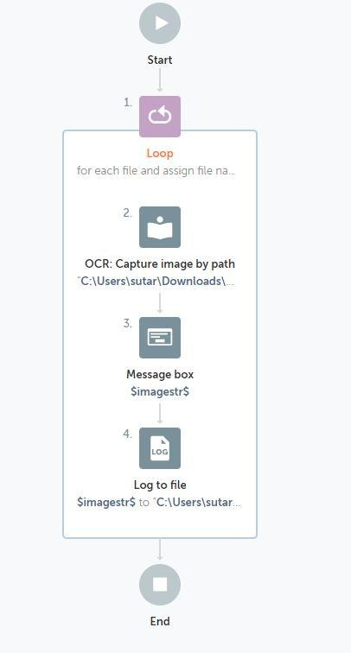

**MCA SEMESTER II**

# Robotic Process Automation Course Code: MCALE23 Assignment 4.1

**Bot**: **To Extract Data from Excel Extracting a particular Cell Value:**

Step 1: Using **Excel advanced:Open** action open the Excel file from the path D:\Sudeshna2021\RPA\Hosting Games Demo.xlsx

Step 2: Using **Excel advanced: Go to Cell** action place the cursor in a specific cell C2 in order extract Dates of the event from the excel file.

Step 3: Using Excel advanced: Get single cell read a particular cell value into a variable

$Data1$

Step 4: Display the Variable value using **MessageBox** action

# Extracting a Multiple Cell Values:

Step 1: Using **Excel advanced:Open** action open the Excel file from the path D:\Sudeshna2021\RPA\Hosting Games Demo.xlsx

Step 2: Using **Excel advanced: Get multiple cell** action read the contents from cell C2 to cell C9 in to a table variable $ExcelSheetData$

Step 3: Loop through each row in a table $ExcelSheetData$

* 1. Assign the value of every record in the iteration into Record variable

$DateRecord$

* 1. Display the Date value using **MessageBox** action

# Extracting Records based on condition and saving it in an Excel:

Step 1: Using **Excel advanced:Open** action open the Excel file from the path D:\Sudeshna2021\RPA\Hosting Games Demo.xlsx in Session 1

Step2: Using **Excel advanced:Open** action open the Excel file from the path D:\Sudeshna2021\RPA\Output\Hosting Game Output1.xlsx in Session 2

Step 3: Using **Excel advanced: Get multiple cells** retrieve the values of multiple cells in an excel worksheet opened in Session 1

Step 4: Use Loop iterating for each row in worksheet. It loops through all rows in excel file of Session 1 and retrieves each record in a variable $ExcelRow1$

Step 5: Create a number variable $var1$ and assign it a value 2

# If number $ExcelRow1[4]$ Greater Than (>) 1000

* 1. Use **Excel advanced: Set Cell** assign specific cell A$var1.Number:toString$ to **$ExcelRow1[0]$ in Session 2**
  2. Use **Excel advanced: Set Cell** assign specific cell B$var1.Number:toString$ to **$ExcelRow1[1]$ in Session 2**
  3. Use **Excel advanced: Set Cell** assign specific cell C$var1.Number:toString$ to **$ExcelRow1[2]$ in Session 2**
  4. Use **Excel advanced: Set Cell** assign specific cell D$var1.Number:toString$ to **$ExcelRow1[3]$ in Session 2**
  5. Use **Excel advanced: Set Cell** assign specific cell E$var1.Number:toString$ to **$ExcelRow1[4]$ in Session 2**
  6. Use **Excel advanced: Set Cell** assign specific cell F$var1.Number:toString$ to **$ExcelRow1[5]$ in Session 2**
  7. Perform **Number: Increment** to increment $var1$ by 1

# Bot Name: ExtractFromExcel

**Flow**

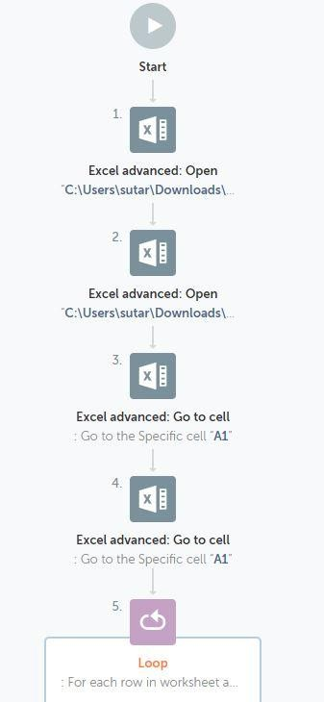

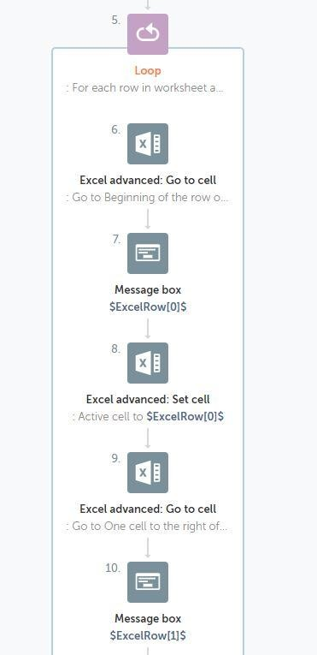

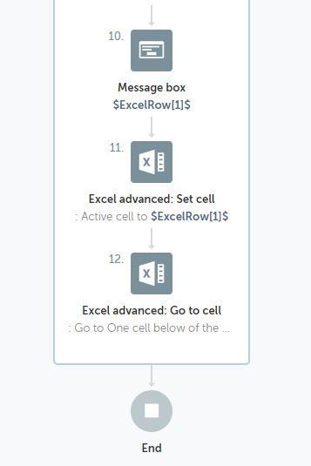

# MCA SEMESTER II

**Robotic Process Automation Course Code: MCALE23 Assignment 5.1**

**IQ Bot** is the only AI solution that you can quickly train to automatically read a variety of complex documents and extract field-level information. IQ Bot gives you access to pretrained AI models (domains) for reading invoices, purchase orders, and other documents. It also allows you to train your own domains to support new document types.

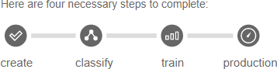

1. **Upload**: Prepare and upload sample documents, create an IQ Bot Learning Instance.
2. **Analyze**: IQ Bot will automatically organize similar documents into groups and map fields with areas on the document.
3. **Review**: You will review field mapping for each group and make necessary corrections. IQ Bot will learn from these corrections and improve the accuracy of data extraction.
4. **Publish**: After completing IQ Bot training, you can use the Learning Instance in production by calling it from RPA Task bot.

# Bot : Design IQ Bot

Step 1: Goto **IQ Bot>Learning Instances** and then click **Train Other Documents**

* 1. Click **Get Started** Button

Step 2: **Create New Learning Instance** and provide the general information

1. Provide **Instance Name** Instance1_demo1**, Document Type** Invoice**, Upload your documents** upload 2 files
2. Deselect all fields under Items Repeated
3. Wait till the documents are analyzed and classified( i.e. Apply classifier, Perform semantic analysis, Learning from aliases, Recognize patterns, Extracts data with respect to every document uploaded)

# Step 3: Review the mapping and To train a group:

* Click each field (left panel) to verify the label and value (center panel) is the same as the document (right panel).
* Preview the mapping after all fields are verified.
* Save and go to the next group.
* Finally save the current training

Step 4: Set to Production

**IQ Bot Learning instance**: Instance1_demo1

# Create a RPA Task Bot to upload documents for processing to IQBots

Step 1: Use a **Loop** Iterating for **each file in folder** and create a dictionary variable

$FilesInvoives1$

1. Use **IQ Bot: Upload Document** and select the **Learning Instance Name** Instance1_demo1 and provide **path** as C:\Users\admin\Desktop\IQBotSampleDocs\Invoices\**$FilesInvoices1{name}$**.**$FilesInvoic es1{extension}$,** Create a variable to hold the result as $ResultOfIQBot$
2. Add a **Message Box** to display the message Invoice uploaded for processing**$ResultOfIQBot$**

Step 2: Use **IQ Bot: Download All Documents**

1. Provide the **server Instance Name** Instance1_demo1
2. Provide the **Path for Local Output Folder**

C:\Users\admin\Desktop\IQBotSampleDocs\Output

1. Save the responses to a variable $IQBotDownload$
2. Add a **MessageBox** to diaplat the message Result Downloaded: **$IQBotDownload$ Bot Name**: IQBotDemo

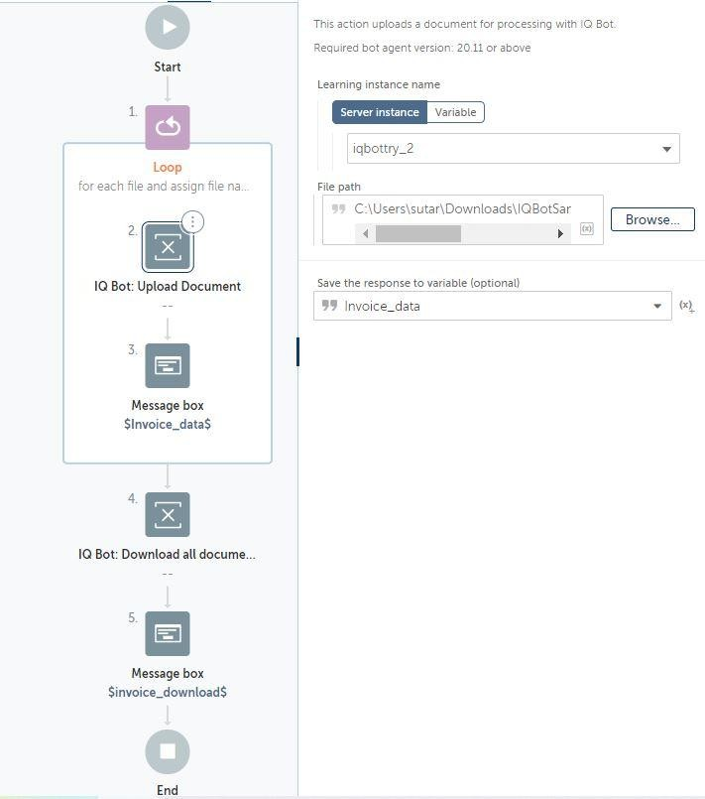

# MCA SEMESTER II

**Robotic Process Automation Course Code: MCALE23 Assignment 6**

# Introduction to UiPath in Robotic Process Automation (RPA)

Robotic Process Automation (RPA) is the automation of workflows using softwares or robots. This process reduces human interaction in these workflows.

RPA allows users to configure robots or softwares that enforce business processes through the integration of human actions with digital systems. RPA software collects data and orchestrates applications using the user interface. They interpret data and communicate with other applications to perform various repetitive tasks.

UiPath is one such RPA tool that can be used for various forms of automation such as [Citrix](https://www.uipath.com/) [automation](https://www.uipath.com/), [PDF automation](https://docs.uipath.com/activities/docs/read-pdf-files), [Web automation](https://docs.uipath.com/activities/docs/read-pdf-files), and [Windows desktop automation](https://www.uipath.com/solutions/technology/desktop-automation).

In web automation, UiPath enables the web developers to perform various actions like data extraction, application transfer, report generation, and website testing.

This tool can be integrated with technologies such as Artificial Intelligence (AI), Business Process Management (BPM), and Enterprise Resource Planning (ERP). Its end-to-end solutions enable users to automate redundant tasks. The main programming language used in this tool is Visual Basic (VB).

# UiPath components

The following are the components of UiPath:

* **UiPath Studio:** This component uses visual aids such as diagrams and flowcharts to design automation processes. It also involves the coding and sequencing of these processes. It consists of Graphical User Interface (GUI) buttons, drag and drop features, and pre-built templates.
* **UiPath Robot:** In this component, multiple bots are deployed to execute the automation processes using pre-defined rules.
* **UiPath Orchestrator:** This component functions as a web-based application that schedules, deploys, and manages processes.

**Why UiPath is widely used?**

The following are the reasons why UiPath is widely used by developers and organizations:

* **Compliance:** It can help an organization to comply with industry regulations, since it supports internal review.
* **Cost-effectiveness:** This tool is cost-effective because there are minimal operational costs.
* **Security:** The security features of UiPath prevents users from various forms of attacks. When a user tries to log into the system using a different computer, it will automatically end the previous session (login).
* **Community-centric:** It offers a free trial in its community edition with an active community support with tutorials and tips.
* **Speed and accuracy:** It completes tasks faster and with greater precision as compared to humans.
* **Customer experience:** It is an effective way of improving customer experience.
* **Productivity:** It boosts productivity in an organization, since many tasks can be completed simultaneously within a short time.

Features of UiPath

* **In-built recorder:** Users can record their activities using its in-built recorder.
* **Scalability:** It has effective debugging handling mechanisms. It can also handle various AI applications.
* **Hosting options:** Hosting can be done in a virtual terminal or a cloud.
* **Central repository:** It consists of a centralized repository that enhances simultaneous handling of robots by users.
* **Application compatibility:** UiPath is compatible with various applications, including desktop and web applications.
* **Scrapping functionality:** It has an advanced scrapping functionality (wizard-driven) that allows users to perform data scrapping. Users can scrape data from various applications.

**How UiPath works?**

Understanding the UiPath architecture can help us understand how it works. The image below shows the architecture of UiPath:

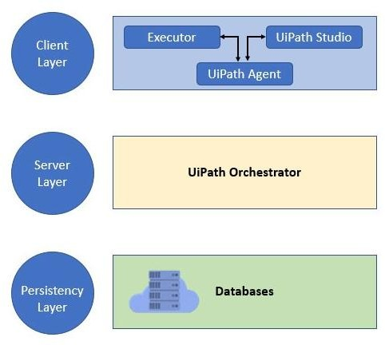

UiPath works in three layers: the client layer, server layer, and persistency layer.

*Client Layer*

This layer consists of UiPath components that can be accessed by users. These include UiPath Robots, UiPath Studio, executors, browsers, and the UiPath agent. A developer can use these components to design various tasks that need to be automated.

The **UiPath agent** plays the role of a mediator between the server and the client. It provides an avenue for communicating information. Users can see available jobs in the system tray using this tool.

The agent can change the system settings and enable the current jobs to start or stop. The software robots uses the **executor service** to execute tasks in the window application.

*Server Layer*

This layer displays all the server details. The whole project is uploaded here once the robots have been fully developed for the execution of tasks.

The server layer consists of an orchestrator that performs various functions such as monitoring activities, scheduling robots, and generating reports.

*Persistency layer*

This layer contains database servers that store the configuration details of the software robots. These include the users’ data, logging information, asset details, and assigned tasks.

**Reference for UIPath Tool:** [**https://www.javatpoint.com/uipath**](https://www.javatpoint.com/uipath)